Green nanostructured biodegradable materials
Short Review
Part II

O. Figovsky¹, D. Beilin²
¹Nanotech Industries, Inc, Daly City, CA, USA
²Polymate Ltd-INRC, Migdal HaEmek, Israel
Abstract: The article presents a brief overview of the work in producing and studying of environment friendly nanostructured polymeric composites. Preparation technology and main applications of the nanocellulose (NanoCell) is described. Novel environment friendly hydrophobic polymer composites were developed. These composites consist of a thick layer of cellulose substrate and a thin protective layer of a biodegradable polymer. Various types of the layer composites and their applications in production of packaging materials are described. The proposed biodegradable nanocomposite coating increases strength of the natural packaging materials and serves effective barrier against water and grease. Wastes of the novel polymer materials can be utilized in two ways: by repulping and by biodegradation. Widespread usage of the proposed polymer composite materials will bring about an improvement in the ecological state of the environment. Method for preparation of the reactive nanocellulose biocarrier and discussion about its biomedical and cosmetic applications are described as well.
Keywords: nanocellulose, biocarier, biodegradable materials, nanocopmosite polymer coating, packaging materials, ecological safety.

Продолжение. Начало работы опубликовано под тем же названием в предыдущем выпуске журнала «Инженерный вестник Дона» № 1, 2016 г.

Biodegradable packaging materials BHM

Kraft-paper with a density of 50-70 g/m² and cardboard with a density of 300-400 g/m² were selected as cellulose substrates. Films of biodegradable plastics [23] :
- Mater-Bi (Novamont Co.)
- Natura (Natura Co.),
- Biopol (Monsanto Co.)

were used for protective coating of the cellulose substrates. The biodegradable plastics Mater-Bi and Natura contain polycaprolactone (PCL) and starch; Biopol contains poly-hydroxy-butyrate-valerate (PHBV).
The novel various biodegradable hydrophobic polymer materials (BHM) in the form of aqueous dispersions were applied [24]. :
- BHM-B - the basic type of BHM) was synthesized by emulsion polymerization of vinyl acetate with the addition of a small amount of acrylic acid and other needed reagents. The concentration of vinyl acetate and acrylic acid copolymer (VAC) in BHM-B emulsion is 35-45%. BHM-B is intended to create a grease-repellent coating on the surface of cellulose substrate. Other types of BHM composition were also developed.
- BHM-GW intended to create a grease- and water-repellent coating, was prepared by the addition of a cross linking agent (for example, dime thy lolurea) to the basic BHM emulsion.
- BHM-W is intended for waterproof coating; it was prepared by the addition to the basic BHM emulsion of a cross linking agent and an emulsion of the natural Carnauba wax.
- BHM-U - two-layer-deep barrier coating of the type was applied on the substrate surface: the first, primer, layer consists of BHM-B and the second layer consists of a hot-melt glazing composition of natural wax, higher aliphatic acids and natural fillers.

Polymer films were applied on the substrate surface by means of lamination technology. Coating of the cellulose substrate with BHM emulsions and compositions was carried out by bar coater. Emulsion-coated substrate was dried at a temperature of 150-180 °C.
The layer composites created have "bread- butter" (A) or "sandwich" (B) structures (Figure 16[25]). These composites can consist of a thin (10-30 micrometer) protective coating layer (1) and a relatively thick (0.5-2 mm) layer of cellulose substrate (2).

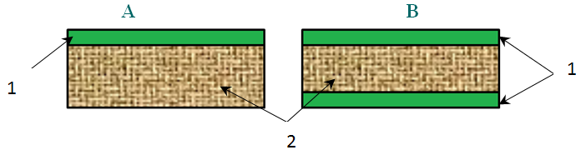

Figure 16. Structure types of the layer composites: 1- polymer coating; 2- cellulose substrate
Production scheme of the coating process is illustrated in Figure 17

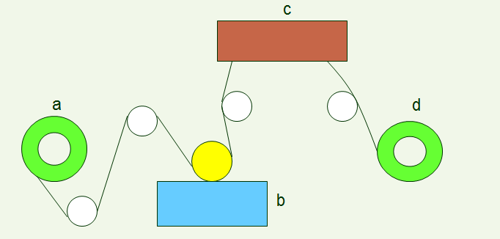

Figure 17. Scheme of coater: a-Unwind station; b- Coating station; c- Drier; d- Rewind station

The effective size (diameter) of micropores in a protective coating layer was measured by the method of water vapor sorption. The effective diameter of micropores was calculated in accordance with the equation [25]:

d = 4V_{p} / S

where S is the specific surface of a polymer material and V_{p} is the specific volume of micropores measured at a relative humidity close to 1.
For example, the BET isotherm of water vapor sorption for Coating A is shown in the Figure 18[25]. The calculated specific surface (S) of the polymer coating is 35 m²/g and specific volume of micropores (V_{p}) is 0.37 cm³/g; Therefore, the effective diameter of micropores (d) in Coating A is about 42 nm.
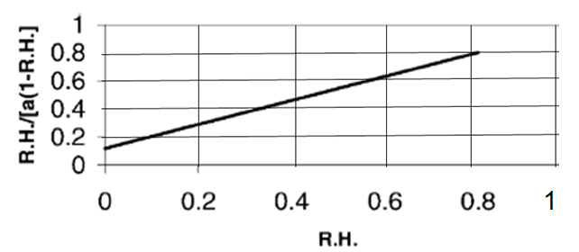
Figure 18. The BET isotherm of Coating A

The following barrier properties of composite materials were studied:
- Water vapor transmission rate (WVT) through a sample tested at normal conditions (25°C, R.H. = 0.85) [26].
- Absorption of liquid water for 30 min (A) measured by the Cobb Test method [27].
- Permeation of O₂ (P[O₂]) [28].
- Grease penetration (Kit no.) tested by the 3M Kit method [C6].
- Time of biodegradation (t) and weight loss of the composites in composting conditions were measured by the methods [29, 30].
- Repulping degree (R.D.) of the composite materials was checked by method [31].

Results and discussion

The barrier properties of the layer composite materials having various protective coatings are shown in Table 9[25].
Table 9. Barrier Properties of the Various Layer Composites

Coating  (thickness 25 μm) | Kit no. | A  g/m² | WVT  g/day m² | PO₂
Mater-Bi | 12 | 13 | 330 | 16
Natura | 12 | 11 | 270 | 14
Biopol | 12 | 5 | 40 | 9
BHM-B | 12 | 9 | 110 | 10
BHM-W | 8 | 3 | 30 | 9
BHM-GW | 12 | 7 | 100 | 10
BHM-U | 12 | 1 | 4 | 7

As can be seen from the experimental results, the value of grease penetration is similar for all the composites studied. However, there is a considerable difference in other barrier properties of the various materials. The coatings of Mater-Bi and Natura do not insure that the composite materials constitute a barrier against water penetration, or moisture and oxygen permeation. The best barrier properties observed are for the composite having the BHM-U coating.
The effective diameter of the micropores (d) and time of degradation (t) in the various coatings of the composite materials is shown in Table 10[25] .

Table 10. Sizes of micropores and time of degradation in the coatings

Coating  (thickness 25 μm) | D  nm. | t  months
Mater-Bi | 60 | 2
Natura | 42 | 2
Biopol | 17 | 5
BHM-B | 30 | 3
BHM-W | 16 | 5
BHM-GW | 20 | 3
BHM-U | 5 | 6

The smallest micropores, with an effective size of about 5 nm, were found for the composite having the BHM-U coating; and the largest, about 60 nm, were found for the material having the Mater-Bi coating.
In order to prevent pollution of the environment waste materials should be broken down and destroyed. The waste of all advanced composite materials is biodegradable and can be decomposed in composting conditions. Decreasing the thickness of the protective coating leads to a reduction in the time taken for biodegradation. Another way of to get rid the waste is to repulp it and then use the recycled composites in the paper industry. This is preferable to biodegradation of the waste.
As can be seen from the results (Table 11[25]), the composites having coatings of the BHM type are repulpable, while the composites having coatings of Mater-Bi, Natura or Biopol are non-repulpable and that limits their application

Table 11. Repulping degree (R.D.) for various types of layer composite materials

Coating  (thickness 25 μm) | R.D.  % | Note
Uncoated substrate | 100 | Repulpable
Mater-Bi | 38
Natura | 36 | Non-repulpable
Biopol | 31
BHM-B | 93
BHM-W | 90 | Repulpable
BHM-GW | 86
BHM-U | 83
A correlation between the sizes of the coating micropores and the properties of the layer composite materials was found. Decreasing the micropore diameter of the protective coating reduced the water absorption and moisture and oxygen permeation, as well retarding the biodegradation process of the composite materials (Table 11, Figures 19-21 [25]).
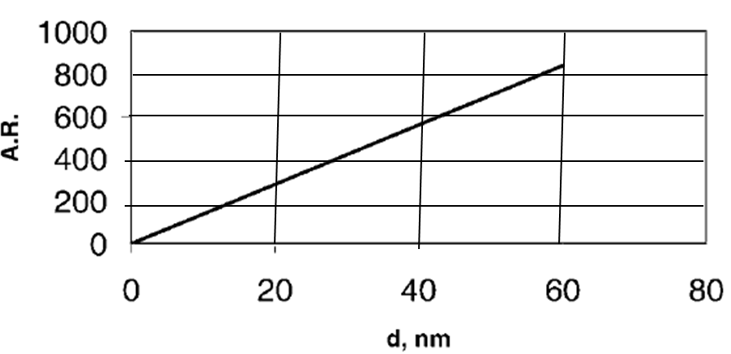
Figure 19. Correlation between micropore size (d) and rate of liquid water absorption (A.R.).
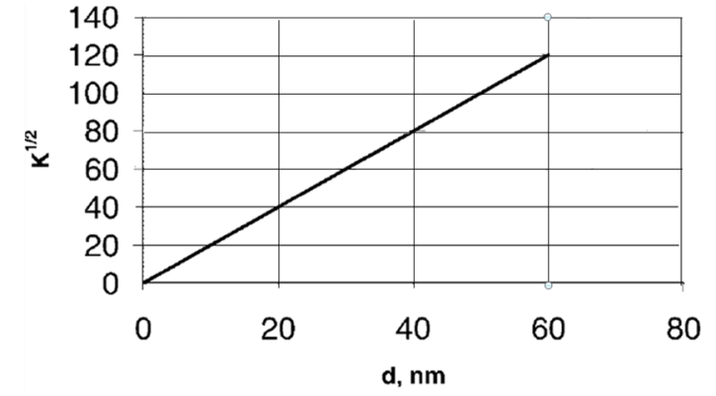
Figure 20. Correlation between micropores size (d) and coefficient of water vapor transmission (K).

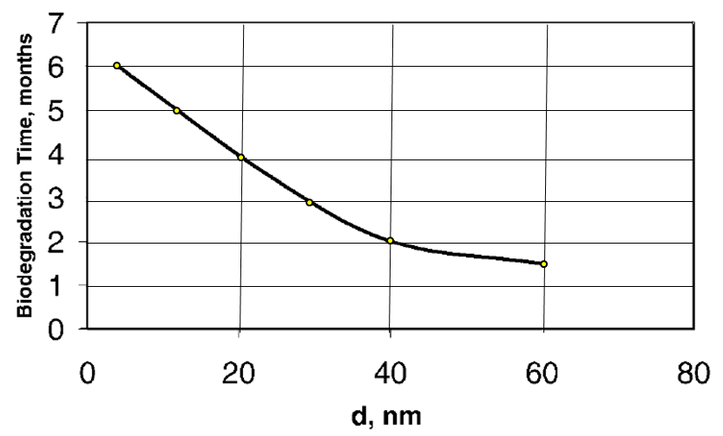
Figure 21. Dependence of biodegradation time of composite materials on size of micropores in protective coatings

The larger micropores and poor barrier properties of the composites having PCL-based polymer coatings (Mater-Bi and Natura) can be explained by the loose packing of the supermolecular structure in these polymer layers. The more dense supermolecular structure of PHBV-based Biopol coating and VAC-based BHM coating insures better barrier properties in the composite materials.
Sizes of micropores and the barrier properties of the dense two-layer BHM-U coating are similar to polyolefin coating. Therefore, the environment- friendly, recyclable composite material having this coating can be used as instead of the environment- polluting, non-recyclable polyolefin-based laminate.
The Table 12 contains for example characteristics of lBT version of BHM aqueous polymer emulsion.

Table 12. Characteristics of 1BT- version of BHMaqueous polymer emulsion.
Characteristics | Value
Solid content, (%) | 35-36
Density, (g/cm³) | 1.03-1.05
Viscosity, (cps) | 100-150
pH | 7-7.5

Properties of cardboard coated with lBT-version of BHM are following (Table 13).

Table 13. Characteristics of cardboard coated with lBT-version of BHM
Characteristics | Value
Coating weight, (g/m²) | 5-10
Tensile strength, (MPa) | 40-50
Cobb Value for 30 min, (g/m²) | 10-20
WVT (g/day m² at RT) | 50-60
3M Kit number | 6-7
Time of biodegradation, (months) | 2-4
Repulpability | Repulpable

It should be noted that within the framework of the patent [24] eighteen different cellulose waterproof biodegradable composites are described in detail. These composites consist essentially of cellulose and hydrophobic polymer-based component.

The composition of the polymer-based component comprises:
- 45-94 weight % of a first polymer, which is preferably polyvinyl acetate, said polymer is capable of cross- linking and contains about 2 to 8 wt % of free hydroxyl groups.
- 4-28 weight % of a second polymer, which is none cross-linked and capable to impart to the first polymer improved elastic properties.
- 2-20 weight % of a cross-linking agent, having at least two functional hydroxyl, carboxyl, amine and/or aldehyde groups.

Specific properties of the suggested cellulose composites are shown in the Table 14 [24] below.

Table 14. Properties of the cellulose composites

Cellulose composites, no. | 1 | 2 | 3 | 4 | 5 | 6 | 7 | 8 | 9
Water absorption, wt, % | 13 | 11 | 12 | 5 | 18 | 21 | 5 | 17 | 14
Water absorption, after folding wt, % | 13 | 12 | 12 | 7 | 19 | 23 | 6 | 30 | 15
Weight loss ,% for 3 month due  to biodegradation | 93 | 90 | 93 | 88 | 95 | 100 | 72 | 100 | 100

Table 14. (Continued)

Cellulose composites, no. | 10 | 11 | 12 | 13 | 14 | 15 | 16 | 17 | 18
Water absorption, wt, % | 4 | 3 | 26 | 10 | 5 | 7 | 6 | 3 | 2
Water absorption, after folding wt, % | 6 | 4 | 30 | N/A
Weight loss ,% for 3 month due  to biodegradation | 70 | 55 | 95 | 93 | 90 | 88 | 92 | 84 | 80

As is shown in [24] the equivalent ratio of functional groups in cross-linking agent to the stoichiometric content of free OH-groups in the PVA, should be 0.4 to 1.2. It has been empirically revealed that if the above ratio is less than 0.4 the cross-linking process does not take place; and if the ratio is more than 1.2 the cross-linking degree is not increased and does not render the obtained composite material more waterproof. It is advantageous, if the weight ratio PL/PVA lies in the range 0.05 to 0.43 and PL-content in the polymer-based component lies in the range 4 to 28 wt %. Decreasing PL/PVA ratio below 0.05 or PL-content below 4 wt % renders the obtained composite material more rigid (cracks after folding) and less waterproof (see example 8). Increasing of PL/PVA ratio above 0.43 or PL-content above 28 wt % renders the obtained composite material less biodegradable (see example 7).

Basic principles for biodegration of polymers
The decomposition process of the waste of the novel composite materials and articles in wet soil occurs under the effect of various microorganisms, fungi and bacteria. These microorganisms exude hydrolases, esterases, peptidases, oxydases, reductases and other enzymes, which are biological catalysts of the degradation process.
Аn organic polymer is capable of biodegradation if it contains specific bonds sensitive to enzymatic destruction, as example, esteric (1), acetalic (2), peptide (3) bonds [32]:
(1) -R-0--OO
(2) -R-0C--0-
(3) -R-NH~C=0

Natural hydrophilic polymers such as cellulose starch, proteins and others and also synthetic hydrophilic and hydrophobic polymers, having the above-mentioned specific bonds, are biodegradable.

Biodegradation of elaborated hydrophobic polymer coating occurs in wet soil under normal enzymatic action of various microorganisms - fungi and bacteria, as follows:

- In aerobic conditions (top soil layers)
C_{n}H_{m}O_{k} (BHM) + O₂ + enzymes = CO₂ + H₂O + Biomass (Humus)
- In anaerobic conditions (lower soil levels)
C_{n}H_{m}O_{k (}BHM) + enzymes = CH₄ + Biomass (Humus

The decomposition of the biodegradable composite occurs in three basic steps [32]:
- The first step is the process of the enzymatic detachment of lateral groups, as example:

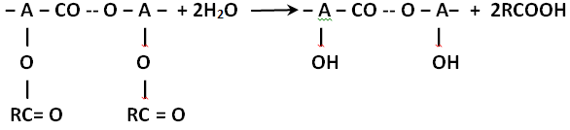
- The second step is the process of the enzymatic depolymerization as example:

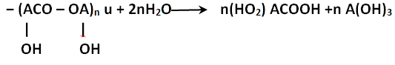

- The third step is the metabolic conversion of monomeric products into water, carbon dioxide (in aerobic conditions) or methane (in anaerobic conditions), as example.
Microorganisms of soil after finish of their vital function are converted into humus. Thus, only the environment friendly substances are formed as result of an organic polymer biodegradation in aerobic conditions: water, carbon dioxide and humus. There are also additional factors that are influenced on decomposition of biodegradable polymers. Increasing in degrees of polymerization and crystallinity delays biodegradation process of a polymer. Porous polymer decomposes fester than monolithic, and glass-type polymer decomposes slowly than elastic.
Decomposition of cellulose base coated with BHMat composting conditions is only slightly longer than the basic cellulose material (Figure 22). Moreover the coated cellulose substrate is repulpable and can be utilized together with uncoated cellulose materials
Soil microorganisms, after finishing their vital function, are converted into humus. Thus, in aerobic conditions only environment-friendly substances are formed as a result of the decomposition of biodegradable polymer material.
The coated substrates - novel layer composites - are produced on a basis of plant raw materials. The end products - water, carbon dioxide and humus - formed as result of biodegradation of the composite materials, are returned to their natural sources (Figure 23 [25]).
The layer composites made by lamination with films of Mater-Bi, Natura, Biopol, etc. are biodegradable, but non-repulpable. Only composite materials having BHM-type coatings are both biodegradable and repulpable. Widespread use of the novel composite materials will improve the ecological state of the environment.
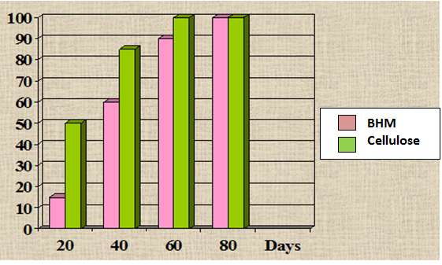
Figure 22.Weight loss, % of materials in wet soil
It should be noted that within the framework of the patent [24] eighteen different cellulose waterproof biodegradable composites are described in detail. These composites consist essentially of cellulose and hydrophobic polymer-based component.
The composition of the polymer-based component comprises:
- 45-94 weight % of a first polymer, which is preferably polyvinyl acetate, said polymer is capable of cross- linking and contains about 2 to 8 wt % of free hydroxyl groups.
- 4-28 weight % of a second polymer, which is none cross-linked and capable to impart to the first polymer improved elastic properties.
- 2-20 weight % of a cross-linking agent, having at least two functional hydroxyl, carboxyl, amine and/or aldehyde groups.

..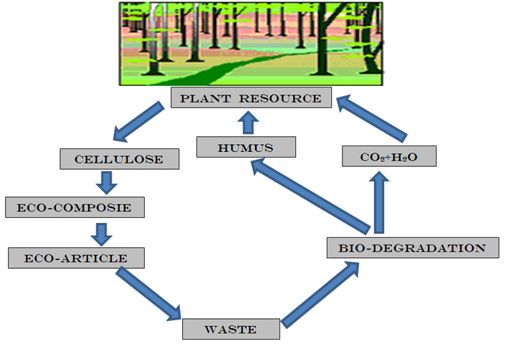

Figure 23. Biodegradable cycle of the novel composite material in nature

Application of the novel biodegradable packaging materials

- Everyday Items: Trash bags, grocery bags, cups, plates, tablecloths and other household goods, etc.
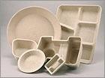

- Packaging Materials: Carton boxes, disposable containers for food processing; Bags, boxes and containers for industrial products, building materials and chemicals, etc.

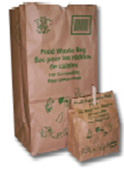

- Agricultural Use: Composting bags for agriculture wastes, bags for fertilizers, mulch sheets, flowerpots, seeding planter trays, etc.
- Textile and Polymer Industry: Hydrophobizing of natural textile materials; Production of synthetic leather, Biodegradable membranes, etc.
- Sanitary Products: Protection layer for disposable hygienic materials like diapers, sanitary napkins, panties, towels etc.
- Other Applications: Water-and grease resistant paper/board; Filler binding; Paper sizing; printing compositions, etc.

NANO-CELLULOSE AS PROMISING BIOCARRIER

Materials and methods

The pure cotton cellulose (DP=3000, 98.7% α-cellulose) was used as initial cellulose materials. The initial cellulose was treated with cellulase complex of Trichoderma reesei in a bioreactor. In order to prevent aggregation of the fine particles, all experiments were carried out using never dried or non-water dried samples. The bio-hydrolyzed cellulose was washed and squeezed on vacuum filter, and the wet cake was chemically modified to introduce form carbonyl and some other type of specific functional groups. Then, BAS, e.g. an enzyme, was coupled to the specific groups. The semi-product was diluted with water and dispersed by high-pressure homogenizer APV-2000 [33].
Average degree of polymerization (DP) of the cellulose samples was measured by Cuen-viscosity method. Diffract meter Rigaku-Ultima Plus (CuK– radiation, λ=0.15418 nm) was used for X-ray investigations. Degree of cellulose crystallinity and average lateral size of crystallites was calculated according to improved methods [34, 35]. The particle size distribution and the average particle size of aqueous suspensions were tested by a method of laser-light scattering using Malvern's Mastersizer-2000 apparatus. Scanning electron micrographs were obtained with a Hitachi S-430 apparatus.
Activity of free and coupled drugs was tested by standard biological methods.
Results and discussion

The process for preparation of the biocarrier includes the following main steps:

1. Controlled bio-depolymerization of initial cellulose up to minimal "level-off" DP; Washing and squeezing to obtaining "wet-cake".
2. Modification in order to introduce specific functional groups and joint various biologically active substances to fine cellulose particles.
3. High-power mechanical disintegration of the modified cellulose particles in liquid media to produce dispersions of the bioactive nano-cellulose.

This process can be represented by means of the following scheme:

Step 1: Enzymatic hydrolysis

The initial cellulose is treated with the cellulase complex allowing selective cleavage of the macromolecular chains in the poorly ordered non-crystalline domains. The catalytic splitting of the poorly ordered domains promotes mechanical disintegration and forming superfine particles uniform distributed in a liquid medium (Figure 24[36]):
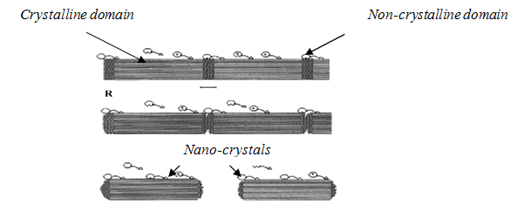
Figure 24. Scheme of enzymatic hydrolysis

Step 2 : Modification

To provide chemical coupling between the carrier and BAS, the specific functional groups (FG) should be introduced into particles, e.g. carboxyl, carbonyl, amine, epoxy, etc., (Figure 25 [36])

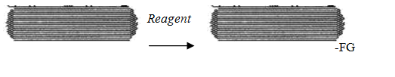
Figure 25. Scheme of modification

The non-dried particulate carrier having specific reactive groups that are able quickly interact with various bioactive substances (BAS) at optimal conditions allowing chemical attachment and forming of carrier-BAS complex (Figure 26 [36]):

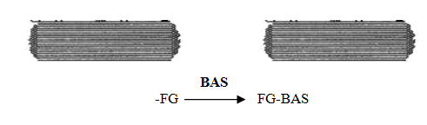
Figure 26. Scheme of attachment BAS to FG of the carrier

Step 3: High-power mechanical disintegration

Uniform length distribution of the nanocarrier particles in the water dispersion is shown in Figure 27 [36]

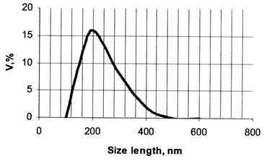

Figure 27.Distribution of the nanocarrier particles in the water dispersion

The structural characteristics of the nanocarrier having low amount of carbonyl groups (0.3-0.5%) are presented in Table 15 [36]

Table 15: Main characteristics of the nanocellulose carrier

Characteristics | Value
Crystalline modification | CI
Degree of crystallinity, % | 78-80
Degree of polymerization | 100-120
Average particle length, nm | 150-200
Lateral particle size , nm | 20-40
Length of crystallites, nm | 40-60
Lateral size of crystallites | 10-12
Electron microscopic investigations showed, the suspension of the nanocellulose carrier contains rod-like particles having length of 150-200 nm and lateral sizes of 20-40 nm (Figure 28 [36]).
Since individual nanocrystallites have diameter of 10-12 nm and length of 40-60 nm, each such nanoparticle is built from aggregates comprising about 2-4 of the crystallites.
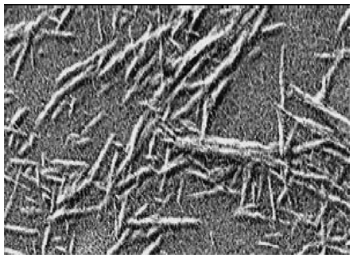
Figure 28. SEM of rod-like particles of the nanocellulose carrier

Activity of the nanocarrier

To check activity of the coupled BAS the standard testing methods were used. For example, the activity of some enzymes was investigated by UV/VIS-spectroscopic method using specific substrates.
The free enzyme is are low stable in the aqueous solutions and it quickly deactivates, particularly at increased temperatures. In contrast to the free enzyme, the enzyme coupled to nano-cellulose carrier is stable in the aqueous medium even at heating (Figure 29[36]

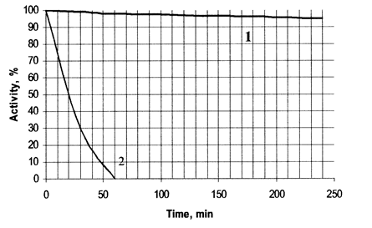

Figure 29. Activity of the coupled (1) and free (2) Trypsine in aqueous media at 60ºC

Applications

The application potential of the cellulose nano-carriers can be immense. Due to these unique properties and unlimited sources of the raw material, the biocarrier can find wide application in various health care branches, such as cosmetology, personal care, dermatology, otolaryngology, dietary food, biotechnology and some others.
The cellulose nanocarrier containing attached proteolytic enzymes can be used in cosmetology’s gentle skin peeler, while containing bound amino acids - as excellent nutrient agent for the skin. The carrier containing bound lipases can be used for selective degreasing of the skin. Nano-carrier with coupled proteolytic enzymes can be used in medicine for treatment of wounds, burns and also post-operating scars, while containing attached anesthetics - as an anti pain agent.

CONCLUSION

The organic nano-cellulose products have average particle size 100-300 nm in the form of water-based dispersion, paste and dry powder. Introducing of NanoCell to composite materials (plastics, paper compositions, adhesives, etc.) imparts them some peculiar properties, such as light-weight increased strength raised biodegradability, cost saving, etc. Moreover, Nano Cell improves properties of water-based paints and coatings. Wide application of the organic Nano Cel-products can create new nanomaterials having unique characteristics and properties
♦
♦ ♦
The main problem of natural biodegradable packaging materials is their susceptibility to water, grease and various other liquids. To solve this problem, the special protective nano-coating was developed and applied onto surface of these biodegradable substrates.
The green technology for preparation of the nanocoating containing nanoparticles of cellulose and inorganic filler, as well as the biodegradable hydrophobic polymer was proposed. This technology is zero-discharge because it provides a full utilization of the raw-materials. The initial cellulose pulp hydrolyzes completely and turns into the solid nanocellulose. Sulfuric acid turns into the solid inorganic nanofiller, while the residual acid returns and uses repeat for the hydrolysis step. The organic solvent after coating of the substrates is condensed to utilize again
As known, the paper, starch and other natural packaging materials contain micron-scale pores. Filling of these micro-pores with nanoscale particles in combination with polymer binder and some other additives closes the pores and thus makes the natural packaging materials more stable against effect of water, grease and other penetrable liquids. Therefore, the nanocoating containing the solid nanoparticles with average size about 200 nm imparts to natural packaging materials increased dry and wet strength, effective barrier against water and grease. Since the coating composition contains mainly biodegradable ingredients, the coated substrates can decompose in the nature during the relative short time.
The novel package materials consist of cellulose, biodegradable polymers and other biodegradable organic additives. Proposed nanostructured polymer coating (NPC) is hydrophobic, oil-, fat- and gasoline resistant, strong, inexpensive, recyclable and biodegradable. Due to biodegradable nature the package materials decompose in wet soil during two-three months by enzymatic action of various micro-organisms, such as fungi and bacteria, pretty much similar to ordinary paper forming a biomass. All the components of the materials have the FDA approval as food packaging materials.
The main advantages of various NPC versions are followings:
- High Strength.
Tensile strength is 40-60 MPa. Such strength characteristics, especially combined with low elongation and acquired water resistance of the material, make NPM unique and highly desirable for packaging applications
- Water Resistance.
NPC has a good water resistance to the cellulose basic material. Thus it has excellent prospects for many packaging applications. Most of the existing biodegradable packaging is not hydrophobic and fails in wetting conditions.
- Grease and Oil Resistance.
NPC is stable against greases, oils and non-polar organic solvents. Common paper and cardboard packaging is grease and oil penetrable.
- Recyclable.
NPC can be recycled and repulped like as basic material - cellulose, paper, board etc.
- Degradation in the Environment.
Natural microorganisms begin breaking down NPC and NPC Cellulose Substrate in water presence. Then microorganisms decompose the material with occurring metabolic reactions. The material is converted into carbon dioxide, water and biomass at composting in wet soil during 2-3 months. Thus this process completely coincides with the definition of biodegradability given by most experts.
- Relatively Low Cost.
The main obstacle to widespread use of biodegradable polymers is high cost. New biodegradable polymers: Mater-Bi, PLA, Biopol, etc. are significantly more expensive than common biostable polymers: PE, PP, PET, and PVC. This expensiveness blocked the widespread adoption of biodegradable plastics in major consumer application. The high costs involved in the production of biodegradable polymers means that they cannot compete favorably with conventional polymers. NPC can be manufactured on the base of relative cheap components, with the existing industry equipment using existing technologies. Paper or board with NPC is only insignificantly more expensive to produce than to produce paper or board itself. Currently available degradable materials on the other hand can cost twice as much.
- Harmless.
NPC not contains harmful components. It is environment friendly and FDA -approved.
♦
♦ ♦

The cellulose nanocarrier has the following general features:
- Natural, biocompatible and harmless permitting use as a health care agent,
- Specific functional groups and developed surface promotes to expressed reactivity,
- Superfine and soft particles contribute to gentle sensation ,
- Excellent compatible with various organic ingredients ,
- Insoluble in water, oils and organic solvents ,
- Permits increasing the locale concentration of attached BAS ,
- Ensures slow-release effect of attached BAS,
- Increases stability of attached BAS to decomposition and deactivation
- Due to expressed thickening effect it imparts rheological properties ,
- Settling stability enables homogeneity of liquid-based systems.

The carrier-BAS complex has increased stability against external factors. Moreover, due to developed surface, this product can form high viscous suspensions and pastes that are convenient for applications. Various BAS-types such as enzymes, biocides, anesthetic, cosmetic and active health care agents can be attached simultaneously to the reactive nanocarrier.
Due to superfine nano-size, the particles of cellulose nanocarrier having coupled BAS are capable clean skin's micron-scale pores, open them and penetrate through the epidermis within the skin strata. This effect of the biocarrier can be employed at development of advanced types of biomedicals and cosmetics remedies used for gentle care and effective treatment of the skin.

REFERENCES

- Swift G. Non-medical Biodegradable Polymers: Environmentally Degradable Polymers. In: Handbook of Biodegradable Polymers, Harwood Academic, Amsterdam, 1997.
- Griffin G. J. L. Synthetic Polymers and the Living Environment. Pure and Applied Chemistry, 52, p. 399-407 (1980).
- Gautam R., Bassi A.S., Yanful E.K., A Review of Biodegradation of Synthetic Plastic and Foams. Appl Biochem Biotechnol. 141 (1), pp.85-108, 2007.
- Ioelovich M. Structure and Properties of Cellulose-based Biodegradable Hydrophobic Materials. J. Scientific Israel. Technological Advantages, 1(2), p.75-81 (1999).
- http://www.marketsandmarkets.com/PressReleases/paper-paperboard-packaging.asp.
- http://www.businesswire.com/news/home/20151216005732/en/Research-Markets-Global-Paper-Packaging-Market-Worth.
- http://www.envsec.org/publications/vitalwaste3_rus_1.pdf.
- http://ec.europa.eu/environment/waste/studies/pdf/plastics.pdf.
- Ioelovich M., Figovsky O., Leykin A. Biodegradable Nano-Composition for Application of Protective Coatings onto Natural Materials. US Pat. No 8268391 (2012).
- Perez J., Munoz-Dorado J., de la Rubia T., Martınez J. Biodegradation and Biological Treatments of Cellulose, Hemicellulose and Lignin: An Overview. Int. Microbiol. 5, p. 53–63 (2005).
- Degli-Innocenti F., Tosin M., Bastiol C. Evaluation of the Biodegradation of Starch and Cellulose under Controlled Composting Conditions. J. Env. Polym. Degrad. 6, p.197–202 (1998).
- Schwach E., Averous L. Starch-based Biodegradable Blends: Morphology and Interface Properties. Polym. Interface.53, p.2115–2124 (2004).
- Lu D.R., Xiao C.M., Xu S.J. Starch-based Completely Biodegradable Polymer Materials. Express Polymer Letters, 3(6), p. 366–375(2009).
- Zhang X.Y., Niu J.N., Tian Q.L. Study on the Biodegradability of Protein Fibers and Their Products in Activated Sludge. Adv. Mater. Res., 602-604, p. 1227-1230 (2012).
- http://www.drugdeliveryreport.com/articles/ddr_w2005_article10.pdf.
- Ioelovich M., Leykin A.,Bioresources.Vol.3, (2008), p 170.
- Ioelovich M., Leykin A., Nano-Cellulose and its Applications, , Journal "Scientific Israel- Technological Advantages", Vol.6, No.3-4, 2004 pp.152-0157.
- Ioelovich M. Dizhbite T. Plotnikov O. Effect of Parameters of Cellulose Supermolecular Structure on Stable Free Radicals upon γ-Radiation. - Cellulose Chemistry and Technology, 31. p. 291- 295 (1997).
- Ioelovich M. Concept of the Native Cellulose Structural Organization. - J. Scientific Israel. Technological Advantages. 1. No 1. pp.68-77 (1999).
- Battista O.A. Mtcrocn stalline Cellulose. - In: Cellulose and Cellulose Derivatives. Parts 4-5. Ed. by N.M.Bikaies and L.Segal. Wiley Interscience. N.Y. London. Sydney. Toronto. 1971.
- loelovich M.. Gordeev’ M. Crystallinity of Cellulose and its Accessibility during Deuteralion, Acta Polvmerica. 45. p. 121-123, (1994).
- Ioelovich M., Figovsky O., Green Nano-Protective Coating , Journal “Scientific Israel- Technological Advantages" Vol.15, № 2, 2013
- Witt U, Muller R, Klein J. Biologisch Abbaubare Polymere: Status und Perspektiven.FPZ: Braunschweig, 1997.
- Ioelovich M, Figovsky O. Hydrophobic biodegradable cellulose containing composite materials. US Patent no. 6294265.
- Ioelovich M., Figovsky O., Advanced Environment-friendly Polymer Materials, Polym. Adv. Technol. 13, 1112-1115 (2002).
- Standard Test Method for Water Vapor Transmission of Materials.ASTM E 96.
- Standard Test Method for Water Absorptiveness of Nonbibulous Paper and Board (Cobb Test).ASTM D 3285.
- Standard Test Method for Gas and Vapor Permeation through Polymers.ASTM D 1434.
- Quality Control of Treaded Paper and Board.3M Kit Test.
- Standard Test Method for Mildew (Fungus) Resistance of Paper and Paperboard.ASTM D 2020 B.
- Determination of Weight Loss of Plastic Materials Exposed to Aerobic Compost. ASTM D 6003.
- Ioelovich M., Engineering of Environmental Friendly Polymer Materials , Journal "Scientific Israel- Technological Advantages", Vol.3, No.1-2, 2001 pp.152-157
- Ioelovich M., Leykin A.,Cellulose Chem. Technol. Vol. 40, (2006), p. 313.
- Ioelovich M., Acta Polymerica. Vol. 43, (1992), p. 110.
- Ioelovich M., Journal "Scientific Israel- Technological Advantages",. Vol. 1 (1999), p. 68.
- Ioelovich M., Figovsky O., Nano-Cellulose as Promising Biocarrier, Journal "Scientific Israel- Technological Advantages", Vol.10, No.1, 2008.

