Experimental qualification for compressive properties
of unidirectional carbon-fiber reinforced composite

J.-K. Wu¹, J.-P. Huang^{1, 2}, O.D. Alekseeva³, V.S. Shevtsova³, M.S. Shevtsova^{4, 5}
¹ National Kaohsiung Marine University. Kaohsiung city, Taiwan R.O.C.
²Southern Federal University, Rostov on Don, Russia
³Don State Technical University, Rostov on Don, Russia
⁴South Center of Russian Academy of Science, Rostov on Don, Russia
⁵RheinMain University of Applied Science, Wiesbaden, Germany

Abstract: Most important information about an environmental resistance (moisture, cyclic change of the temperature, ultraviolet radiation) of high strength composite material can be received at the compressive mechanical testing. The reinforcing fibers that are oriented along the specimens’ axis (or are oriented on the small angles relative to this axis) carry the main tensile loading. Conversely, at the compression the elastic and strength properties of the material basically depend on the matrix properties. The specimens for mechanical testing are usually manufactured as relatively thin rectangular plates by winding or laying-up that corresponds to the ready composite parts. In order to eliminate buckling of the specimen at compressive test, its working length must be much shortened. So, this working part is unavailable for the extensometer instalaltion, and compressive strain of the specimen can be determined by the stroke of crosshead only. This stroke is a sum of very small contraction of the specimen and crosshead displacement due to elastic deformation of the testing machine. We determined the dependence of elastic deformation of the testing machine at the preliminary testing to exclude this deformation from the testing data. We present the features of the compressive testings and their numerical processing at the study of high strength GFRPs, and also the character of composite fracture studied by means of the scanning electron microscopy.
Keywords: Polymeric composite materials, multilayered composites, environmental resistance, experimental technique, compressive testing, scanning electron microscopy.

1. Introduction
The low density, high strength, high stiffness to weight ratio, excellent durability, and design flexibility of fiber-reinforced polymers are the primary reasons for their use in many structural components in the aircrafts, automotive, marine and other industries. Most of these products experience high environmental action such as moisture, temperature changes, ultraviolet radiation, which influence on the operational conditions of the machines. In particular, the rise in moisture and temperature reduces the elastic modules and strength of the material and induces internal initial defects, which may affect the stability as well as the safety of the structures [1 - 4]. Hence, the changes in mechanical characteristics due to the hydrothermal effects seem to be an important consideration in composite analysis and design, which are of practical interest and were studied by the many authors.
Transport of moisture in epoxy composites, occurs in three stages below the glass transition temperature. In the first stage, absorbed moisture occupies the free volume present in the form of voids. In the second stage, the absorbed moisture attacks the polymeric network sites resulted in the form of swelling and in the third stage, water finally enters the densely cross-linked region [5, 6].
Effects of moisture can be observed in the fiber, resin and fiber–matrix interface. Most of the glass and carbon reinforcements are not susceptible to moisture absorption because of good hydrolytic stability. In polymeric composites, the most exposed constituent to moisture is resin. Physical changes like plasticization and swelling and chemical changes like hydrolysis and chemical scission are usually severe and these can lead to significant reductions in strength and toughness properties. Furthermore, the structural integrity and lifetime performance of polymeric composites are strongly dependent on the stability of fiber–matrix interfacial region. The fiber–matrix interface is often affected by moisture absorption, destroying the fiber bonding and providing space for the water to reside. Hence, the fracture of laminated composites exposed the environmental action is observed in the form of delamination or matrix destruction, and most informative testing methods oriented to estimate the degradation of mechanical properties of composites are short-beam bending and compression tests. These testing results do not depend on the properties of reinforcement, but on the matrix and fiber-matrix interface only [7, 8]. However, the precise monitoring of the samples strain at the compressive tests is very difficult because of impossibility of use the extensometers. It difficulty follow from the narrow testing area on the specimens that is made to eliminate the specimen’s buckling due to high compressive force [7, 9]. At these conditions, the specimen’s strain can be determined by displacement of crosshead of the testing machine only.
The present study involves development of experimental technique to implement the reliable and repeatable compressive testing and investigates behavior of unidirectional carbon-fiber reinforced plastic (CFRP) at the high compressive stress up to its ultimate values. Finally, we demonstrate some results of study the fracture maps observed by scanning electron microscopy (SEM). Our results demonstrate the ability of developed experimental technique to estimate the environmental resistance of high strength reinforced plastics with a good sensitivity.

2. Test method, specimens and fixture
All tabbed specimens (see Fig.1) that match to modified ASTM D695, Boeing BSS 7260 and SACMA SRM 1-94 standard, satisfy for all dimensional tolerances. These CFRP specimens that represent unidirectional lamina (0⁰ warp) are not recommended for modulus determination due to difficult use of strain gauges and extensometers [9].
Due to absence of fixture recommended by the standards named above (not applicable for testing of produced structures) the test fixture recommended by ASTM D6641 / D6641M - 09 Standard Test Method for Compressive Properties of Polymer Matrix Composite Materials Using a Combined Loading Compression (CLC) [10] is used (see Fig.2). When tabbed specimens, typically unidirectional composites, are tested, the CLC test method (combined shear / end loading) has similarities to test methods D 695 (end loading) [10, 11]. When testing lower strength materials such that untabbed CLC specimens can be used, the benefits of combined loading become particularly prominent. All specimens have been tested on TIRA test 2850 testing machine (see Fig.3).

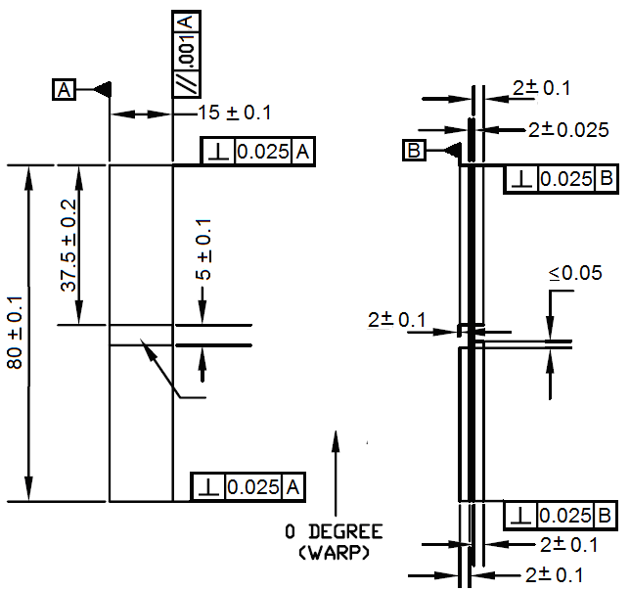 | 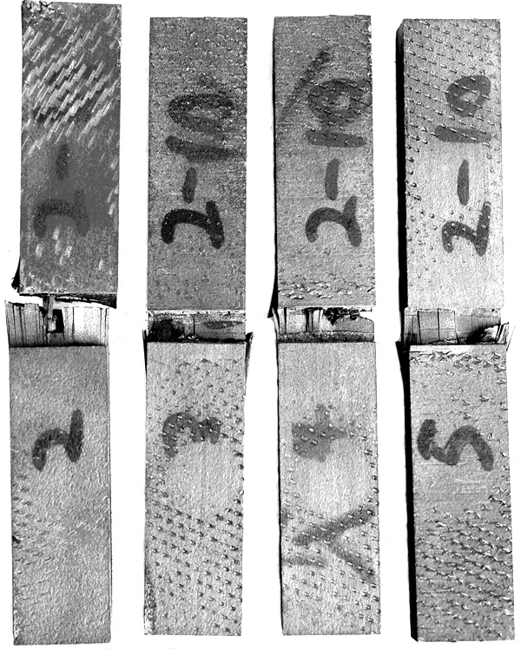
а) | b)
Fig. 1 - Specimens for compressive test
a) Specimen’s sketch; b) Destroyed specimens after compressive test

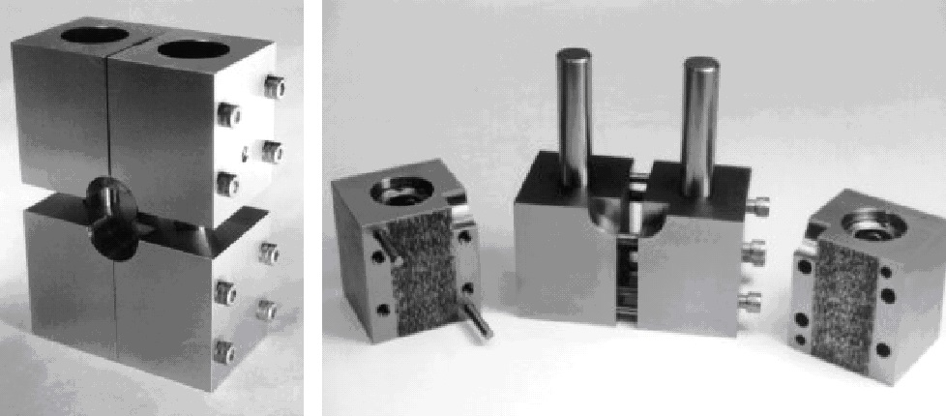
Fig. 2 – Test fixture used for the compressive strength and modulus determination
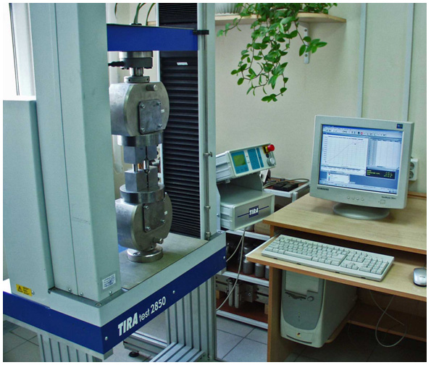  a) | 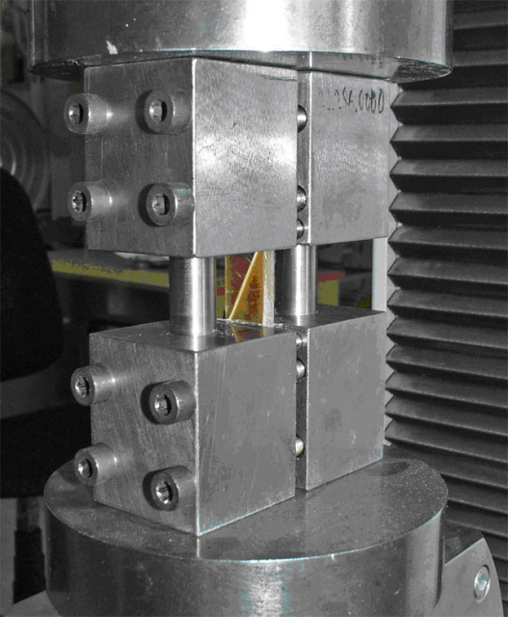  b)
Fig. 3 – Testing machine (a) with compression test fixture (b)

Figure 3 shows the test fixture with specimen after its failure. Side inserts made from stiff plastic are installed for ensure the uniformity of fixing force distribution. Loading force is applied through the tabs (friction force between toothed holding grips and tabs surface) and through both ends by the steel inserts (compression force).
Composite properties in the test direction that may be obtained from test method include [10]:
Ultimate compressive strength,
Ultimate compressive strain,
Compressive (linear or chord) modulus of elasticity, and
Poisson's ratio in compression.
TIRA test 2850 testing machine provides max testing force 50 kN, force resolution 1 N, and crosshead displacement resolution 0.01 mm. For such specimen geometry both supplied extensometers cannot be used because their min measured base is 10 mm. Hence, samples compression strain was measured by the crosshead displacement. In order to exclude own elastic deformation of testing machine together with fixture the test of testing system compliance has been twice preliminary performed (see Fig. 4). After subtracting of free crosshead displacements (before contact with the test fixture) dependence of whole testing system, elastic displacement on the applied force has been approximated by the empiric relationship (see Fig. 4, c), which four model parameters has been determined using least square method. This approximation is used at the numerical processing of testing results for each specimen.
In order to exclude an increasing of friction force in columns, before testing their parallelism has been ensured with precision 0.01 mm at each assembly of fixture with sample.
Loading force is applied with the constant strain rate 1 mm/min.
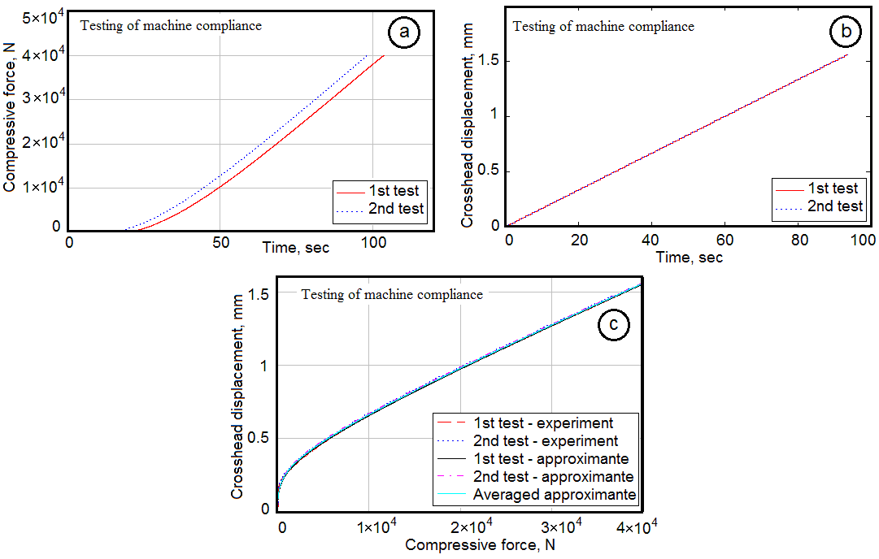
Fig. 4 – Determination of the testing system compliance by two tests:
a) – time histories of applied force;
b) – time histories of crosshead displacement (after subtracting a free crosshead displacement);
c) – comparing the testing data with approximated dependence
of displacement vs applied force
Each testing was terminated at decrease of loading force more 10 N. At this time instant an applied force and a compressive strain (after subtracting own deformation of testing machine) were accepted for calculation of ultimate compression strength and compressive fracture strain

3. Compressive modules determination
All testing data have been issued by the testing machine in the forms of diagrams and *.txt file, which was then subjected by further numerical processing. Because of absence of the customer special instructions, the chord modulus cannot be evaluated. Therefore, for determination of tangent modulus we found in the loading chart a straight-line region which has been approximated by the linear dependence (see plots in Fig. 5). A slope of this dependence we accepted as compressive elastic module. In Fig. 5 we present most important plots for one representative sample No.6.
The initial regions of plots in Fig. 5 are partially distorted because of small differences of machine compliance at each test. These differences are of the same order with displacement sensitivity. However, these distortions do not affect on the calculated values of compressive strength and compressive modulus.

4. Testing results analysis
The mean, minimum, maximum, standard deviations and confidence intervals at probability 0.95 for each determined parameters have been calculated using testing results for 4 specimens. It is useful to look at the plotted dependencies of ultimate strength and compressive modulus on the ultimate strain (see Fig. 6). As can be seen, compressive fracture strain decreases as material stiffness and strength grow. Such regularity is intrinsic for the brittle materials. Indeed, fracture pattern confirm this assertion. In Fig. 7 two pictures of fractured sample are present. Fracture lines are developed both in longitudinal and transversal directions. Many fibers and filaments are separated from each other.
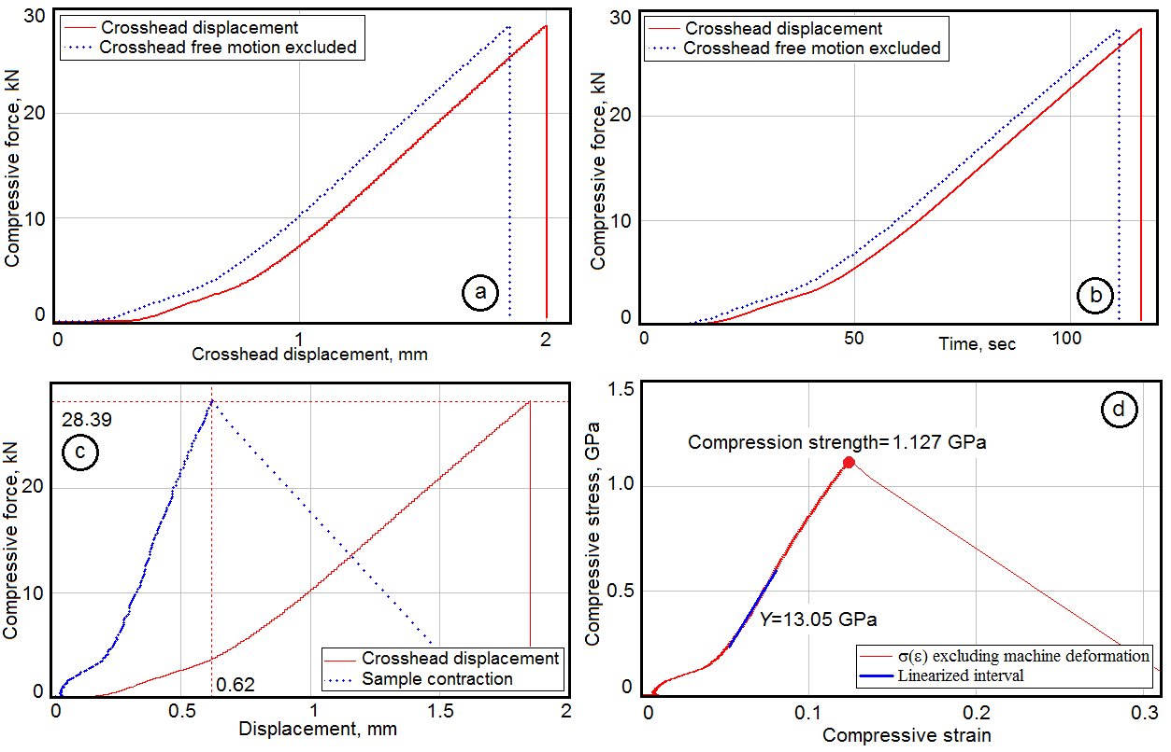
Fig. 5 - Some plots calculated for the sample No.6
a) – loading force vs displacement before and after subtracting free displacement of the crosshead; b) – time history of loading force; c) - loading force vs displacement before and after subtracting the deformation of testing machine;
d) -plot with linear region (blue color) used for calculation of tangent compressive modulus

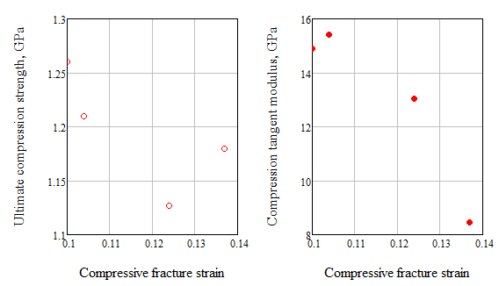
Fig. 6 – Dependencies of compressive strength and compressive module
on the ultimate strain
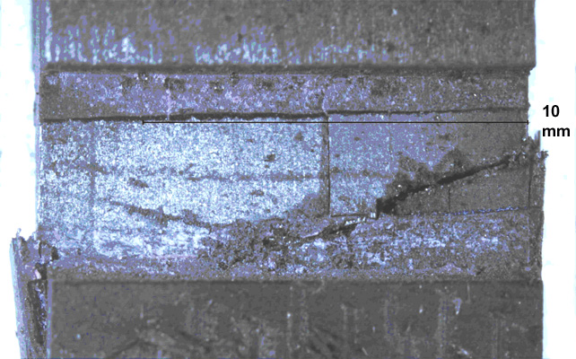 | 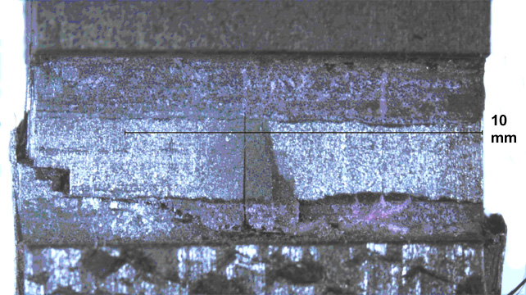
Fig. 7 – Two opposite views of fracture zone for one sample after compression test
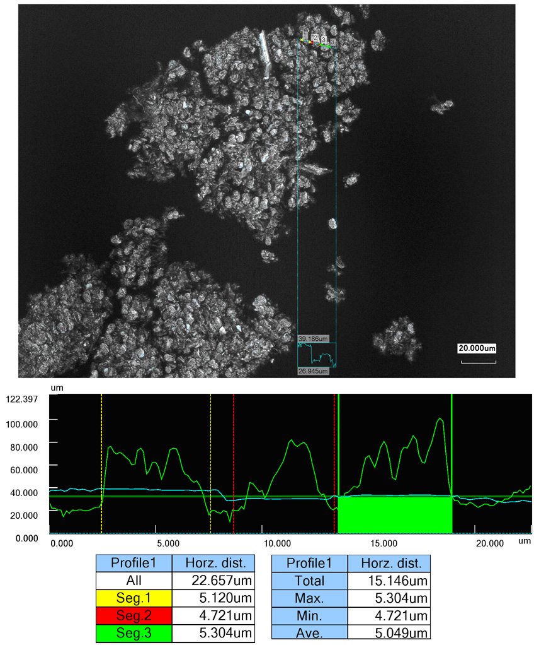
Fig. 8 – SEM analysis pattern and quantitative data of filaments cross-section after specimen destroyed during compressive test
Transversal view of two splitting filaments is presented in Fig. 8 obtained using SEM. Some filaments were splitted that confirms the weakness of the coupling between fibers and resin. Perhaps, resin content in the studied sample is small.
Confidence intervals for the studied material parameters (see Fig.9) are hugely wide because results of only 4 samples were considered. It obvious for more reliable data need more tests. Comparison of the found values for the tangent elastic compressive module with those for the tension, which has confidence interval [110…140] GPa, demonstrates the sufficient (ten times!) difference of CFRP stiffness at the compression and tension.
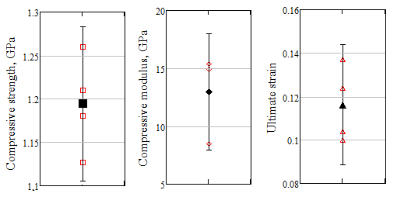
Fig. 9 – Confidence intervals for the studied material parameters
calculated using of testing data at confidence probability 95%

Conclusions
The compressive test technique has been developed and applied to the study of compressive properties of high strength carbon fiber composite. This technique allows providing the satisfactory precision and repeatability of determination the tangent elastic module, ultimate stress and strain even at the testing of high stress brittle composite materials, in particular, to estimate the environmental resistance of materials. Our results confirmed the sufficient difference between tensile and compressive tangent elastic modules that is important to predict long time behavior of composite structures subject to high environmental action. The scanning electronic microscopy reveals the splitting the bunches of carbon fibers before composite failure that is due to brittleness and insufficient adhesion resin to the reinforcing carbon fibers.

Acknowledgments
The authors wishes to acknowledge the valuable technical support from Rostvertol Helicopters Co., Formosa Plastics Corp., and also the partial financial support from the Russian Foundation for the Basic Research (Grants 13-08-90912, 14-08-31612, 15-08-00849) and National Scientific Council of Taiwan (Project 99-2923-E-022-001-MY3).

References
- Rath M.K. and Sahu S.K. Static behavior of woven fiber-laminated composites in hygrothermal environment. Journal of Reinforced Plastics and Composites. 2011, V.30. pp. 1771- 1782.
- Sen I. et al. Variations of mechanical properties of jute/polyester composite aged in various media. Journal of Composite Materials. 2012, V. 46. pp. 2219-2227.
- Mailyan L.R., Aivazyan E.S. Inženernyj vestnik Dona (Rus), 2013, №3 URL: ivdon.ru/ru/magazine/archive/n3y2013/1760.
- Mishnev M.V. et al. Inženernyj vestnik Dona (Rus), 2013, №3 URL: ivdon.ru/ru/magazine/archive/n3y2013/1837.
- Khan L.A. et al. Effect of hygrothermal conditioning on the fracture toughness of carbon/epoxy composites cured in autoclave. Journal of Reinforced Plastics and Composites. 2013, V. 32. pp. 1165-1178.
- Composite Materials Handbook. V.1 Polymer Matrix Composites Guidelines for Characterization of Structural Materials. MIL-HDBK-17-1F, USA Dept. of Defense, 2002, 586 p.
- Manual on Experimental Methods for Mechanical Testing of Composites. C.H. Jenkins Ed., Fairmont Press, Inc., 2003, 263 p.
- Polskiy P.P., Mailyan D.R., Georgiev S.V. Inženernyj vestnik Dona (Rus), 2014, №4 URL: ivdon.ru/ru/magazine/archive/N4y2014/2734.
- Tomblin J.S., Yeow C.N., and Raju K.S., Material Qualification and Equivalency for Polymer Matrix Composite Material Systems, Report DOT/FAA/AR-00/47, 2001, 120 p.
- Standard, A. S. T. M. "D6641/D6641M, 2009”." Standard Test Method for Compressive Properties of Polymer Matrix Composite Materials Using a Combined Loading Compression (CLC) Test Fixture.” West Conshohoncken, PA (2009).
- Chinchan L.V., et al. Mechanical Testing of Polymeric Composites for Aircraft Applications: Standards, Requirements and Limitations. in Advanced Materials: Springer Proceedings in Physics series. Springer International Publishing Switzerland. 2014. pp.201-222.

