New directions of research and development in the field of nanotechnology for the creation and application of inorganic composite materials
Part I

Pavel Kudryavtsev, Nikolai Kudryavtsev, Alex Trossman
Polymate Ltd – Israel Nanotechnology Research Center, Israel,
Abstract. In the paper, we give a brief overview of the main developments made personally and under the direct supervision of the professor, academician RANS andIAELPS P. Kudryavtsev. These developments are devoted to the use of sol-gel processes in various branches of science and technology. Using this process, new composite heat-resistant materials, highly disperse materials and thin filmswere created. These developments have made it possible to create new efficient catalysts and highly selective inorganic ion-exchange materials. Based on inorganic ion-exchange materials, a technology was developed to extract lithium from natural brines, which are poor in lithium content. On the basis of sol-gel technology, new composite matrix-isolated flocculants-coagulants were created. These reagents are designed for the treatment of natural and wastewater in order to remove impurities of oil products and heavy metals.
Keywords: Nanomaterials, Sol-Gel Technology, Nanostructured Materials, Composite Materials, Highly Dispersed Materials, Thin Films, Catalysts, Highly Selective Inorganic Ion Exchangers, Extraction of Lithium, Composite Flocculants-Coagulants.

INTRODUCTION
The present article is devoted to a brief review of technological developments carried out under the guidance of the professor, academicianRANSP. Kudryavtsevat various enterprises in Russia and in International Nanotechnology Research Center Polymatein Israel. These works are devoted to the development of technology for the production of nanostructured inorganic composite materials for various functional purposes.The creation of these materials is based on a deep understanding of the relationship between composition - structure - properties. Regulation of the properties of the resulting materials consists in controlling their structure at the atomic, molecular, and colloidal nanoscale level. The main process used in obtaining the developed materials is sol-gel technology.
Sol-gel technology is a technology of production of materials with specific chemical and physical-mechanical properties, including the production of Sol - colloidal solution, and translating it into gel. Sol-gel technology used in the manufacture of inorganic sorbents, catalysts and carriers of catalysts, synthetic zeolites, knitting inorganic chemicals, ceramics with special thermal, physical, optical, magnetic and electric properties, glass, ceramics, fiber, thin film coating and other.
Sol is a colloidal dispersion of solid particles in the liquid. Colloids are a suspension in which the dispersed phase is the scale dimension in the nanometer range. In these conditions, and are dominating in the van der Waals forces and the Coulomb forces between the surface charges. The inertia of the dispersed phase is small, so there is an effect of Brownian - stochastic particle motion, i.e. the random motion of particles caused by the kinetic energy provided by collisions with each other and with the molecules of the dispersion medium.
Gel consists of continuous solid and liquid phases that have colloidal size. These phases are continuous mutually penetrating systems. The gel formation begins with the formation of fractal structures of clusters of colloidal particles, the growth of these clusters. In the process of growth, they begin to interfere with each other and to be linked with each other. About the point of gelation neighboring clusters of particles are joined together to form a single structural grid. The point of gelation corresponds to the percolation threshold, when a single cluster, as if the enlarged throughout the volume of a colloidal solution. After passing the point of gelation,sol loses its mobility and is converted into a gel. The system changes its properties, turning from Newtonian fluid in Bingham fluid, and it occur ultimate shear stress.
Gel usually takes the shape of the vessel, which was sol. The formation of the gel does not stop at the point of gelation. During the existence of the gel, it is the process of aging. It is related to the processes of structural changes in the gel after the point of gelation. In the resulting gel, single cluster coexists together with sol, which contains many small clusters. This is a continuous process attaching them to a common skeleton - continuous giant cluster. In addition, in gels can continue the condensation reaction that fail to finish in the sols and processes sedimentation of monomers or oligomers, there are phase transitions "solid phase$↔$liquidphase".
During the aging process of gels usually occur shrinkage gels. Shrinkage gel includes deformation of the net of gel and removal of the liquid phase from the pores. This process of the contraction of a gel accompanied by the separating out of liquid is called - syneresis. The process of syneresis usually combined with the process of drying the gel. Dried gel called xerogel. The xerogel often reduced in volume by 5÷10 times in comparison with volume source of gel. There are special methods that allow drying wet gel without destroying its structure. For example, the modern method of obtaining of aerogels (aerogel is the xerogel, which preserved skeleton of the original gel, and pores instead of the remote liquid phase air-filled) is supercritical drying. This gel is placed in the autoclave and dried under supercritical conditions (i.e. under conditions of pressure and temperature, exceeding the critical parameters used solvent), which eliminates the action of capillary forces against the removal of fluid from the pores.
After drying the xerogels are fired in the process of this formed a glass or ceramic material. During burning there are many complex physical and chemical processes related to removing solvents, volatile products of destruction and chemically bound water. There is a structure transformation of inorganic polymer - is the sintering process, and in some cases and crystallization.
The most practical application has oxide systems. The sols and gels of metal oxides can be obtained from aqueous solutions, or it can based on sols with pre-grown particles. These particles have a sufficiently dense solid phase structure.
Sol-gel technology offers monolithic materials (e.g. glass) and superfine powders have porous structure. For the Sol-gel processes as raw materials can be used in a variety of metal alkoxides.

Nanostructured Composite Materials with High Temperature Resistance
Soluble organic based silicates and soluble silicates of alkali metals are use as binders for the production of heat-resistant and chemically resistant materials. Soluble silicates are secure and they have high cohesive strength, low cost, do not corrode, do not evaporate volatile and flammable components and do not degrade the environment in the course of their operation. These materials can be widely used in various branches of the military, aviation, nuclear and missile technology where high-energy flows, developing high temperatures and thus requires the maintenance of high physical and mechanical characteristics of the material appear.
The soluble alkali metal silicates and organic bases are compatible with most inorganic and organic compounds. They have good adhesion to the hydrophilic and hydrophobic surfaces.
Compositions based on organic alkali silicates provide coating productions, which are characterized by excellent adhesion, heat resistance, fire- and corrosion resistance. Depending on the additives, they may be electrical conductors or insulators [1-6, 56].
In rocket and space technologies for the water production the destroyed mandrels used in the manufacture solid fuel rocket engine housings and pressure vessels “cocoon” of composite materials by winding method. It has been studied application of silica sol the use to obtain inorganic nanocomposites ceramics and monolithic blocks of silicon oxide, which can be used in various fields of modern technology. There were shown the possibilities of using silica sol as a binder for the ultra-lightweight refractory thermal protection materials used to protect equipment and products of missile technology from high temperature impacts. Directions for the production of new heat-resistant, acid-resistant materials and coatings to protect equipment, parts and components operating at high temperatures and in corrosive environments have been proposed. Also using sol-gel technology based on soluble silicates the matrix glass-ceramic materials with increased heat resistance and mechanical strength can be created. The general scheme of the sol-gel process is shown in Fig. 1.
Nanostructured additive for producing such composite materials is mainly tetrafurfuriloxysilane. A significant increase in strength and the impermeability of the silicate matrix is achieved by introducing into the composition of additives, esters α-furancarbinol and the orthosilicic acid - tetrafurfuryloxysilane. This effect is achieved due to strengthening contact between silica gel globules and modification of the alkaline component due to the "inoculation" of the furan radical.
The author obtained a positive solution for a patent application for a method for preparing water-soluble silicates containing alkaline organic cations by reacting hydroxides of a strong organic base with amorphous silica in the form of nanodispersed particles [5, 55]. In addition, the presence of organic components in the binder composition improves the thermal stability of the resulting composite materials due to the absence of a mineral alkaline component in their composition.
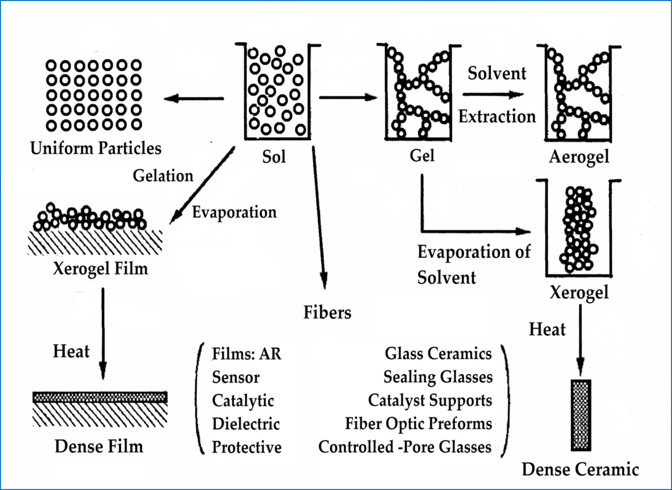
Figure 1. Overview of the sol-gel process with steps [5].

Important factor in increasing of the mechanical strength of composite materials based on soluble silicates as a binder is the reinforcement structure of the composite material, the addition of a mineral glass and ceramic fibers. Figure 2 shows photographs of reinforced matrix composites obtained by sol-gel technology.
A result of performance this work will be developed production technology of component base and composite materials based on organic alkali soluble silicates, nanostructured addition of tetrafurfuryloxysilane or tetrafurfuryloxytitanium with heat resistance of at least 1000 ℃.

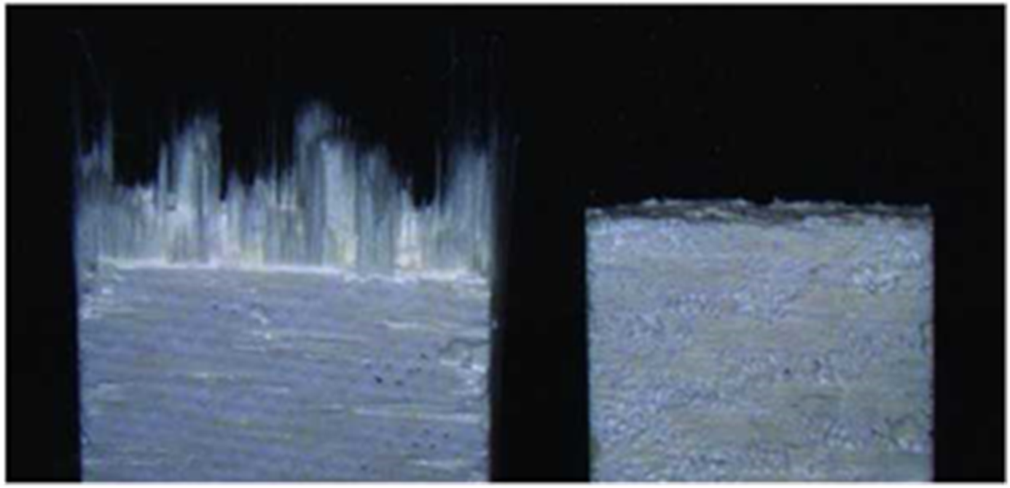
Figure 2. Inorganic Fiberglass Matrix Composite Material SiO₂-SiO₂ resulting sol-gel method. Type of fracture with different strength of the matrix.

Synthesis of Highly Dispersed Materials
The technology of obtaining of highly dispersed materials from metals alkoxides are colloidal solutions - sols. One of the modern processes described in the literature [2] based on hydrolysis of metal alkoxides and polycondensation reaction products, leading to the formation of sol, gel, and then a firm gel. Hydrolysis occurs under the action of catalyst - acid (HCl) or base (NH₄OH). For example, the simplest system is used to obtain sols polysilicic acids is a three-component system tetraethoxysilane(TEOS)-water-ethanol. The catalyst not only affects the rate of hydrolysis, but also on the structure of polycondensation products. In this system in the acidic medium formed linear polymers, but in basic medium formed branched clusters. From alkoxides in the result of hydrolysis, pyrolysis or oxidation get high purity and active metal oxides.
Primary particles sols - colloidal solutions, have the size of 1÷100 nm. This fact determines the further possibility to receive the final powders and other dispersed materials with particle sizes equal to or slightly greater than the size of the primary sols particles.

Obtaining Thin Films
One of the important technological aspects of the application of Sol-gel processes is that, before gelation, liquid - sol or solution is ideal for preparation of thin films using these normal processes as dipping or spraying [7]. Compared with conventional processes for thin films, such as CVD, evaporation or sputtering, Sol-gel processes of formation of a film requires significantly less hardware and potentially less costly. However, the most important advantage of the sol-gel process, in comparison with traditional processes of coating, is possible of accurately control the microstructure of the sedimentary films, i.e., pore volume, size and specific surface area. Control of these factors allows engineers to find the porosity of the film. For example, pore volume can vary from 0 to 65%; pore size from <0.4 nm to >5.0 nm; and surface area from <1 to >250 m²/g.
The films were among the first objects produced by the Sol-gel method [4]. The thickness of the films used in planar technology of microelectronics, is usually 30 to 200 nm. Such nanoscale films obtained from the sols, for example, by centrifuging.
Sol-gel method of films forming in microelectronics was used from the 60th years of the last century. The greatest distribution of such films received as sources of diffusant. The introduction of doping impurities in semiconductor film deposited on its surface is in the process of high-temperature annealing through diffusion alloying elements. Films are also used as a mask, isolation, planarizing and getter coverage. A new and very promising is their use as catalytic coatings in semiconductor gas sensors, membranes with organic molecules immobilized for liquid and gas sensors, membrane fuel cells, as well as major sensitive elements of oxide gas sensors.
The Sol-gel method of making glassy film has a number of significant advantages, and therefore this method has taken a worthy place in semiconductor technology. Sol-gel technology allows many processes in controlled conditions. For example, a functioning successfully protective, insulating, planarizing and getter films can be formed even at a temperature of 250 to 450$℃$. Since the source of diffusion are film with a given regulated by the concentration of doping impurity, deformation and violations of the crystal lattice doped semiconductor minimized [8].
An important advantage of this method of doping is the possibility to introduce impurities first, in these films, then in semiconductor materials a number of doping impurities that are difficult or impossible to enter other methods (doping in the process of growing, ion implantation or diffusion from other sources).
Products of partial hydrolysis and pyrolysis of alkoxides - polyorganometalloxanes components of heat-resistant coatings and surface activators for bonding difficult bonded materials [54].

Catalysts and Carriers of Catalyst
Controlling the processes of syneresis and drying the gel is possible to achieve solid oxide materials with adjustable structure of their pores and the size of their specific surface area.
In the general case:
$$S_{уд}= \frac{k}{a}$$
Where: k is a coefficient depending on the form of particles of which were built of porous structure;
a - particle size.
With the increasing dispersion of colloidal systems, its specific surface increases dramatically. Thus, there are great possibilities of production of porous materials with adjustable porosity and specific surface. In turn, this surface becomes very active and this allows you to fix it different chemical groups, thereby giving the material adjustable set of catalytic and adsorption properties. Such products bear the name of supported catalysts.
Supported catalysts that contain the active ingredient, applied to dispersed or porous material - carrier of catalyst. The use of supported catalysts allows increasing working surface of the catalyst, saves expensive substances (e.g. Pt, Pdand Ag), prevents recrystallization and sintering active component at high temperatures, lengthens the life of the catalyst and in some cases stabilizing it in a certain chemical form. Catalyst carrier should have the necessary chemical properties and adhesion, allowing you to keep on its surface-active component, to ensure easy access reactive substances to the active centers of the catalyst must be thermally and chemically stable in terms of catalysis and regeneration of supported catalysts. The amount of the active component in the supported catalysts is usually significantly smaller than the amount of carrier of catalyst. As carriers of catalysts used artificial materials such as silica gel, Al₂O₃, alumina-silicates, MgO, TiO₂, and ZrO₂ with highly developed specific surface area and porosity.
Some supported catalysts can speed up the catalytic process or cause different reaction, for example on the platinum active centers of supported catalysts of reforming, takes place reaction of dehydrogenation, and on the carrier of catalyst Al₂O₃ - isomerization of hydrocarbons. In some cases, the active components of catalysts can interact with carrier of catalyst. For example in the supported catalysts of hydrocarbons synthesis from CO and H₂ by Fischer-Tropsch method, metal component (Co, Ni, Fe) interacting with the carrier of catalyst (ТhO₂, ZrO₂, TiO₂), which is accompanied by a partial recovery of its and covering metal particles by carrier of catalyst. The dispersion of the metal-supported catalysts strongly depends on carrier of catalyst. The most common way of getting supported catalysts - carrier of catalyst impregnation by solution containing active components catalyst, followed by drying and roasting. For the preparation of catalysts on an oxide support, salts are commonly used that decompose to oxides upon heating. Apply impregnation of deposition on the surface of the catalyst carrier insoluble hydroxides with their subsequent decomposition. The most common industrial media catalyst is silica gel, which has a high specific surface and mechanical strength. It is used for production of industrial supported catalysts of oxidation, polymerization and some other processes. Used as the carrier of the active form of aluminum oxide γ-Al₂O₃ with a specific surface area of 120-150 m₂/g, obtained by the hydrolysis of aluminum ethylates. It is used in preparation of catalysts for oil refining processes. In the deposited catalysts afterburning of industrial emissions, the main carriers of catalysts - heat-resistant metal or silica fiber, in the deposited catalysts afterburning automobile gas - special ceramic cell carriers, which are active γ-Al₂O₃ by method hydrolysis of his alkoxides, and then apply Pt or Pd [9,54].

The continuation of the work published under the same title in the next issue of the magazine “Inženernyj vestnik Dona (Rus)” N 4, 2017.

References
1. Figovsky O.L., Kudryavtsev P.G. Advanced Nanomaterials based on Soluble Silicates, Journal "Scientific Israel - Technological Advantages", Vol.16, no.3, (2014).
2. Kudryavtsev P., Figovsky O. Nanomaterials based on soluble silicates, ISBN 978-3-659-63556-4, LAP Lambert Academic Publishing, 2014, 241 p.
3. Kudryavtsev P., Figovsky O. Nanocomposite Organomineral Hybrid Materials, Journal "Scientific Israel - Technological Advantages", Vol.17, no.3, 2015, pp.7-60, ISSN: 1565-1533.
4. Kudryavtsev P. Alkoxides of chemical elements - Promising class of chemical compounds which are raw materials for HI-TECH industries, Journal "Scientific Israel - Technological Advantages", Vol.16, no.2, 2014.
5. Kudryavtsev P., Figovsky O. The sol-gel technology of porous composites, LAP Lambert Academic Publishing, ISBN 978-3-659-78529-0, 466 p.
6. Kudryavtsev P.G., Figovsky O.L. Method of Producing Soluble Silicates with Organic Cations. US Patent. No: 9,695,111 B2, Receipt Date: 22-SEP-2015.
7. Brinker C. J., Scherer G.W. Sol-Gel Science. The Physics and Chemistry of Sol-Gel Processing. San Diego: Academic Press, (1990).
8. MaksimovA.I., Moshnikov V.A., TairovU.M., ShilovaO.A. Fundamentals of Sol-gel technology of nanocomposites, SPb.: SPbGETU "LETI", (2007).
9. Пахомов Н.А. Научные основы приготовления катализаторов: введение в теорию и практику, Рос. акад. наук, Сиб. отд-ние, Ин-т катализа им. Г.К. Борескова. — Новосибирск: Изд-во СО РАН, 2011. 262 с. ISBN 978-5-7692-1185-0.
10. Kudryavtsev P.G., Onorin S.A., Volkhin V.V., IzvestiyaVUZ. Non-ferrous metallurgy, 3, (1977), 50.
11. Kudryavtsev P.G., Onorin S.A., Inorganic ion exchangers (synthesis, structure, properties), 212, (1977), 105.
12. Volkhin V.V., Leontieva G.V., Onorin S.A., Khodyashev N.B., Kudryavtsev P.G, ShvetsovaT.I., Chemistry and technology of inorganic sorbents, Perm, RF, (1980), 67.
13. Kudryavtsev P.G., Onorin S.A., Volkhin V.V., The method of obtaining of inorganic anion-exchanger, A.S. USSR № 1274763, (1985).
14. Kudryavtsev P.G., Onorin S.A., Volkhin V.V., Solid state chemistry, Sverdlovsk, (1983), 67.
15. Kudryavtsev P.G., Onorin S.A., Volkhin V.V., The method of obtaining of inorganic sorbents for extraction of lithium from solutions, A.S. USSR № 1160627, (1983).
16. Kudryavtsev P.G., Onorin S.A., Volkhin V.V., The method of obtaining of selective for lithium inorganic sorbent, ASSTR № 1203739, (1984).
17. Kudryavtsev P.G., Onorin S.A., Volkhin V.V., The method of obtaining of inorganic anion-exchanger, A.S. USSR № 1125043, (1983).
18. Kudryavtsev P.G., Onorin S.A., Volkhin V.V., The method of obtaining of inorganic sorbent selective for lithium, A.S. USSR № 1256274, (1985).
19. Kudryavtsev P.G., Onorin S.A., Volkhin V.V., The method of obtaining of inorganic anion-exchanger, A.S. USSR № 1189497, (1984).
20. Kudryavtsev P.G., Journal of physical chemistry, 61, 3, (1987), 848.
21. Kudryavtsev P.G., Onorin S.A., The method of obtaining of inorganic anion-exchanger AAT-1, A.S. USSR № 1435280, (1987).
22. Kudryavtsev P.G., Onorin S.A., Volkhin V.V., The method of obtaining of inorganic anion-exchanger, A.S. USSR № 1435281, (1987).
23. Kudryavtsev P.G., Onorin S.A., Volkhin V.V., Chemistry and technology of inorganic sorbents, interuniversity collection of scientific papers, PPI, Perm, (1989), 140.
24. Kudryavtsev P.G., Onorin S.A., Volkhin V.V., IzvestiyaVUZ. Nonferrous metallurgy, 2, (1990), 21.
25. Kudryavtsev P.G., Onorin S.A., Volkhin V.V., IzvestiyaVUZ. Nonferrous metallurgy, 3, (1990), 26.
26. Kudryavtsev P.G., Volkhin V.V., The Sol-gel processes of obtaining of inorganic materials, Perm, (1991), 3
27. Kudryavtsev P.G., Onorin S.A., Volkhin V.V., Izvestiya AN SSSR ser. Inorganic materials, 27, 7, (1991), 1479.
28. Volkhin V.V., Leontieva G.V., Onorin S.A., Izvestiya AN SSSR ser. Inorganic materials, 9, 6, (1973), 1041.
28. Zilberman M.V., Volkhin V.V., J. structural chemistry, 12, (1971), 649.
30. Volkhin V.V., ShulgaE.A., Zilberman M.V., Izvestiya AN SSSR ser. Inorganic materials, 7, (1971), 77.
31. Volkhin V.V., Kolesova S.A., Zilberman M.V., Onorin S.A., J. inorganic chemistry, 16, (1971), 1611.
32. KalyuzhnyA.V., Volkhin V.V., Zilberman M.V., Kolesova S.A., Journal Of Applied Chemistry, 50, (1977), 201.
33. Volkhin V.V., Zilberman M.V., Kolesova S.A., PykhtinaL.I., Tetenov V.V., KalyuzhnyA.V., Journal Of Applied Chemistry, 49, (1976), 1728.
34. Kalinin N.F., Volkhin V.V., Zilberman M.V., IzvestiyaVUZ. Chemistry and chemical Technology, 19, 6, (1976), 865.
35. Leontieva G.V., Burmakin E.I., FarberovaE.A., Bakhireva I., ShachtmanG.S., Volkhin V.V., J. inorganic chemistry, 34, 3, (1990), 594.
36. Kudryavtsev P.G. Lithium In Nature, Application, Methods of Extraction (Review), Journal "Scientific Israel-Technological Advantages", Vol.18, № 3, 2016, pp.63-83, ISSN: 1565-1532.
37. Garret D.E., Laborde M. Recovering lithium from brine by salting out lithium sulfate monohydrate. Pat. USA N 4287163, 01.09.1981.
38. BerzainR.L. Method for concentration of lithium chloride from Salarde Uyuni brines. Rev. Boliv. Quim., 1985, v. 5, N 1, p. 8—20. In CA, 1986, v. 104, ref. N 227124 h.
39. Zil'bermanM.V., Kalinin N.F., ChentsovaT.V., YelizarovaI.A., Antipov M.A., Murav'yevYe.N. Sorption technology for processing natural brine in lithium compound, rubidium and cesium; Chemistry and technology of inorganic sorbents. Interuniversity collection of scientific papers. Perm, ed. Perm PI, 1989, p.5-9.
40. Senyavin MM Krachak AN Nikashina VA Study of lithium adsorption of highly mineralized solutions on different types of inorganic ion exchangers, Chemistry and Technology of Inorganic sorbents, Interuniversity collection of scientific papers, Perm, ed. Perm PI, 1989, s.10-26.
41. Onorin S.A., Volkhin V.V., Method for producing the inorganic ion exchangers, USSR Author's Certificate № 455560, 1972.
42. Volkhin V.V., Leontieva G.V., CheranevaL.G., BakhirevaO.I. Lithium desorption method with an inorganic ion exchanger on the basis of manganese and aluminum oxides, RF patent №1811679, 1991.
43. Kudryavtsev P.G., Onorin S.A., Volkhin V.V. The process for producing inorganic sorbent for extracting lithium from solutions, USSR Author's Certificate № 1160627, 1983.
44. Kudryavtsev P.G., Onorin S.A., Volkhin V.V., Yakimov V.A. The process for producing inorganic sorbent selective to lithium, USSR Patent № 1256274, 1985
45. Onorin S.A., Volkhin V.V. Composition for inorganic ion exchanger, USSR Patent № 451456, 1972.
46. Kruchinina N.E. ASFC as an alternative to conventional coagulants in processes of water treatment production of Ecology. 2006. № 2. p. 46-50.
47. KruchininaN.Ye., TurniyerV.N., Lisyuk B.S., Kim V. A method for producing aluminosilicate coagulant. RF Patent number 2225838 IPC 7, C01F7 / 56, C01F7 / 74, C02F1 / 52.
48. Kudryavtsev P.G., NedugovA.N., et al. A method for producing silico-the flocculant-coagulant and method of cleaning with the help of water RF Patent number 2388693 IPC, C01B33 / 26, C01F7 / 74, C02F1 / 52. 2008.
49. Kim Y.H. Coagulants and Flocculants: Theory & Practice 1st Edition, Tall Oaks Pub; 1995, 96 p. ISBN-13: 978-0927188043.
50. NedugovA.N., Kudryavtsev P.G., Kudryavtsev N.P., et al. A method for producing a composite aluminum-silicon flocculant-coagulant, RF Patent number 2447021 IPC, C01B33 / 26, C02F1 / 52, C01F7 / 74. 2010.
51. NedugovA.N., Kudryavtsev P.G., Kudryavtsev N.P., et al. A method of producing iron-silicon-coagulant flocculant and method of water treatment. RF Patent number 2438993 IPC, C02F1 / 52, C01G49 / 14, C01B33 / 32, B01D21 / 01. 2010.
52. Cradock S., Hinchcliffe A.J. Matrix Isolation. A Technique for the Study of Reactive Inorganic Species, Cambridge Universrty Press, Cambridge, 1975.
53. Kudryavtsev P., Figovskiy O. Matrix-Isolated Nanocomposites - Alumina-Silicon Flocculants-Coagulants, Journal of Physical Science and Application, Vol. 7, № 3, 2017, p. 25-36, DOI:10.17265/2159-5348/2017.03.003.
54. KetovA.A., FazleyevM.P., IsmagilovZ.R., BarannikG.B., Kudryavtsev P.G. The method for producing oxide catalysts. USSR patent № 1615945 by application № 4644450/04, 29.12.88.
55. Kudryavtsev P.G., Figovsky O.L. Inženernyj vestnik Dona (Rus), 2014, №2 URL: ivdon.ru/ru/magazine/archive/n2y2014/2476.
56. Figovsky O.L., Kudryavtsev P.G. Inženernyj vestnik Dona (Rus), 2014, №2 URL: ivdon.ru/ru/magazine/archive/n2y2014/2448.

